**THROUGHPUT AND JITTER CALCULATIONS TESTCASE**

Testcase Writer: Nayana

**Throughput Calculation :** Total user data (or) payload delivered to their respective destination every second is known as throughput.

**Scenario 1:** To check that throughput obtained in Application metrics is same when calculated manually using the formula.

**Case 1: If Simulation Time > Application End Time**

Create a scenario (in any network here Internetwork is chosen as example) as shown in the below screenshot

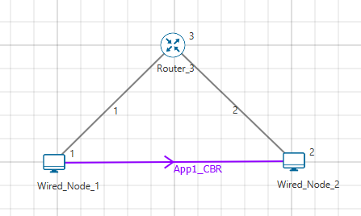

Enable packet trace. In Application set,

Start time = 0 sec,

Application End Time = 10 sec.

And Run simulation for 100 seconds. Calculate Application throughput by using below formula,

𝐴𝑝𝑝𝑙𝑖𝑐𝑎𝑡𝑖𝑜𝑛 𝑇ℎ𝑟𝑜𝑢𝑔ℎ𝑝𝑢𝑡 (Mbps) = 𝑇𝑜𝑡𝑎𝑙 𝑝𝑎𝑦𝑙𝑜𝑎𝑑 𝑑𝑒𝑙𝑖𝑣𝑒𝑟𝑒𝑑 𝑡𝑜 𝑑𝑒𝑠𝑡𝑖𝑛𝑎𝑡𝑖𝑜𝑛 (𝑏𝑦𝑡𝑒𝑠) ∗ 8

𝑇𝑖𝑚𝑒 𝑙𝑎𝑠𝑡 𝑟𝑒𝑐𝑒𝑖𝑣𝑒𝑑 𝑝𝑎𝑐𝑘𝑒𝑡 𝑎𝑡 𝐴𝑝𝑝 𝑙𝑎𝑦𝑒𝑟(𝜇𝑠) − 𝐴𝑝𝑝 𝑆𝑡𝑎𝑟𝑡 𝑇𝑖𝑚𝑒 (𝜇𝑠)

Ie: Application throughput(Mbps) = 731460 * 8 = 0.58516

10000000-0

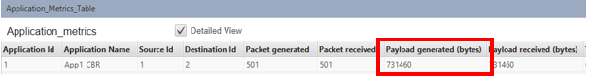

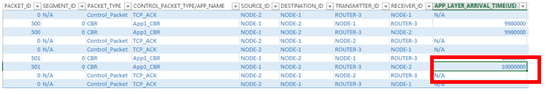

**Expected Result:** Throughput obtained in Application metrics should be same when calculated with above mentioned formula.

**Actual Result:** Same as expected.

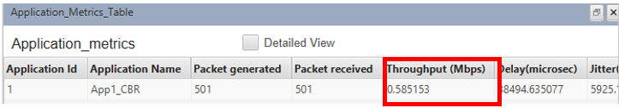

**NOTE:**

1. Application start time, Simulation Time must be converted to micro seconds while calculating using the formula.
2. Time last received packect at APP Layer is obtained from Packet trace, check the last packet time in APP_Layer_Arrival_Time.

**Case 2: If Simulation Time < Application End Time**

Same as Case 1 but in Application set,

Start time = 0 sec,

Application End Time = 100000 sec.

And Run simulation for 100 seconds. Calculate Application throughput by using below formula,

𝐴𝑝𝑝𝑙𝑖𝑐𝑎𝑡𝑖𝑜𝑛 𝑇ℎ𝑟𝑜𝑢𝑔ℎ𝑝𝑢(𝑖𝑛 𝑀𝑏𝑝𝑠) = 𝑇𝑜𝑡𝑎𝑙 𝑝𝑎𝑦𝑙𝑜𝑎𝑑 𝑑𝑒𝑙𝑖𝑣𝑒𝑟𝑒𝑑 𝑡𝑜 𝑑𝑒𝑠𝑡𝑖𝑛𝑎𝑡𝑖𝑜𝑛 (𝑏𝑦𝑡𝑒𝑠) ∗ 8

𝑆𝑖𝑚𝑢𝑙𝑎𝑡𝑖𝑜𝑛 𝑇𝑖𝑚𝑒(𝜇𝑠) − 𝐴𝑝𝑝 𝑆𝑡𝑎𝑟𝑡 𝑇𝑖𝑚𝑒(𝜇𝑠)

Ie: Application throughput(Mbps) = 7300000 * 8 = 0.584

100,000,000 ‬- 0

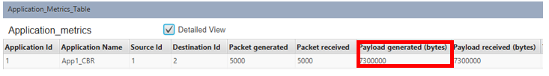

**Expected Result:** Throughput obtained in Application metrics should be same when calculated with above mentioned formula.

**Actual Result:** Same as expected.

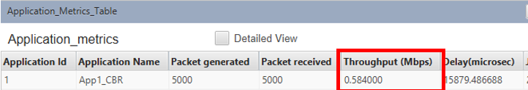

**Case 3: Check with different Start time**

Same as Case 1 but in application set,

Start time = 5 sec,

Application End Time = 10 sec.

And Run simulation for 100 seconds. Calculate Application throughput by using below formula,

𝐴𝑝𝑝𝑙𝑖𝑐𝑎𝑡𝑖𝑜𝑛 𝑇ℎ𝑟𝑜𝑢𝑔ℎ𝑝𝑢𝑡 (Mbps) = 𝑇𝑜𝑡𝑎𝑙 𝑝𝑎𝑦𝑙𝑜𝑎𝑑 𝑑𝑒𝑙𝑖𝑣𝑒𝑟𝑒𝑑 𝑡𝑜 𝑑𝑒𝑠𝑡𝑖𝑛𝑎𝑡𝑖𝑜𝑛 (𝑏𝑦𝑡𝑒𝑠) ∗ 8

𝑇𝑖𝑚𝑒 𝑙𝑎𝑠𝑡 𝑟𝑒𝑐𝑒𝑖𝑣𝑒𝑑 𝑝𝑎𝑐𝑘𝑒𝑡 𝑎𝑡 𝐴𝑝𝑝 𝑙𝑎𝑦𝑒𝑟(𝜇𝑠) − 𝐴𝑝𝑝 𝑆𝑡𝑎𝑟𝑡 𝑇𝑖𝑚𝑒 (𝜇𝑠)

Ie: Application throughput(Mbps) = 366460 * 8 = 0.586336

10000000 - 5,000,000‬

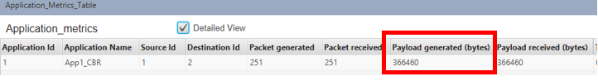

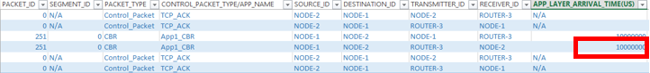

**Jitter Calculation : Jitter** in IP networks is the variation in the latency on a packet flow between two systems, when some packets take longer to travel from one system to the other.**J itter** results from network congestion, timing drift and route changes.

**Sceanrio 2:** To check that Jitter obtained in Application metrics is same when calculated manually using the formula.

**Case 1:** Create a scenario (in any network here Manet is chosen as example) as shown in the below screenshot

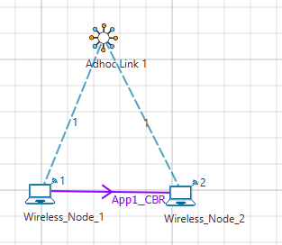

Enable packet trace.

And Run simulation for 100 seconds. Calculate Jitter by using below formula,

𝐽𝑖𝑡𝑡𝑒𝑟(𝜇𝑠) = 𝑇𝑜𝑡𝑎𝑙𝑃𝑎𝑐𝑘𝑒𝑡 𝐽𝑖𝑡𝑡𝑒𝑟 𝑜𝑓 𝑎𝑙𝑙 𝑠𝑢𝑐𝑐𝑒𝑠𝑠𝑓𝑢𝑙𝑙 𝑝𝑎𝑐𝑘𝑒𝑡𝑠

𝑇𝑜𝑡𝑎𝑙 𝑁𝑢𝑚𝑏𝑒𝑟 𝑜𝑓 𝑠𝑢𝑐𝑐𝑒𝑠𝑠𝑓𝑢𝑙𝑙𝑦 𝑟𝑒𝑐𝑖𝑒𝑣𝑒𝑑 𝑝𝑎𝑐𝑘𝑒𝑡𝑠 − 1

Total Packect Jitter of all successful packets is calculated as follows:

STEP 1: Open packet trace and filter the control packets to CBR

STEP 2: Insert a column after PHY_LAYER_END_TIME to calculate the difference between Physical layer End Time and Application Layer Arrival Time as shown in the below screenshot

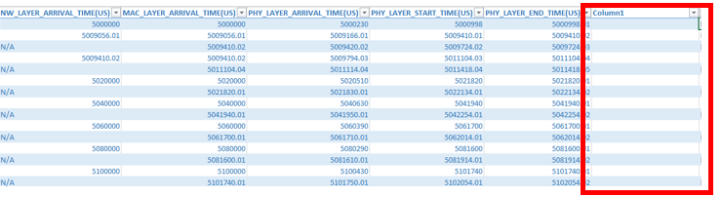

STEP 3: Then apply the below formula in this column :

=[@[PHY_LAYER_END_TIME(US)]]-[@[APP_LAYER_ARRIVAL_TIME(US)]]

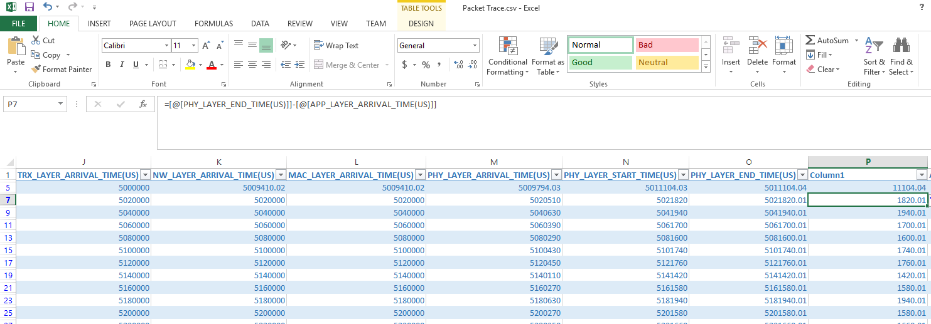

STEP 4: Now Select this entire column and paste in other sheet to perform Packet Jitter calculation.

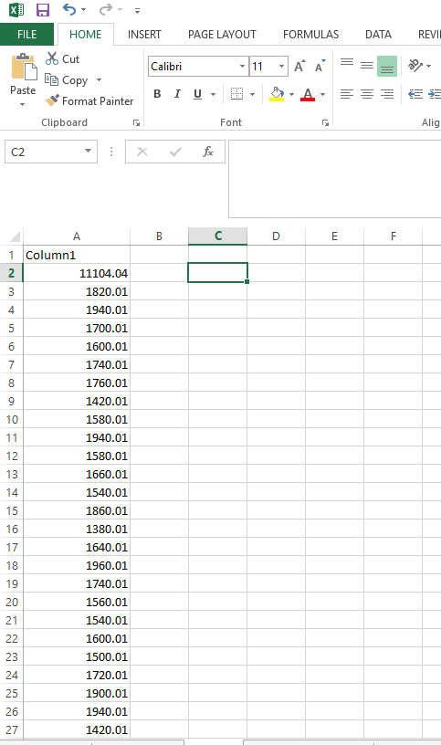

STEP 5: Apply the below formula

𝑃𝑎𝑐𝑘𝑒𝑡 𝐽𝑖𝑡𝑡𝑒𝑟 (𝜇𝑠) = |𝐸𝑛𝑑𝑡𝑜𝐸𝑛𝑑 𝐷𝑒𝑙𝑎𝑦 𝑜𝑓 𝐶𝑢𝑟𝑟𝑒𝑛𝑡 𝑝𝑎𝑐𝑘𝑒𝑡 − 𝐸𝑛𝑑𝑡𝑜𝐸𝑛𝑑 𝐷𝑒𝑙𝑎𝑦 𝑜𝑓 𝑃𝑟𝑒𝑣𝑖𝑜𝑢𝑠 𝑃𝑎𝑐𝑘𝑒𝑡|

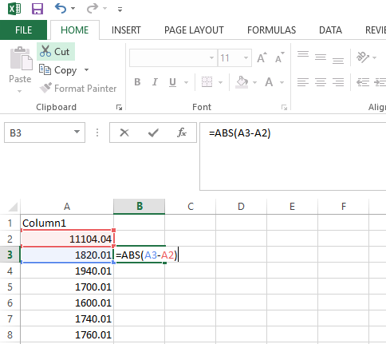

Note: Add ABS to take mod function since this is giving -ve numbers.

STEP 6: From the current value obtained drag the column upto the last value as shown below and note down the Sum obtained below in the packet trace .

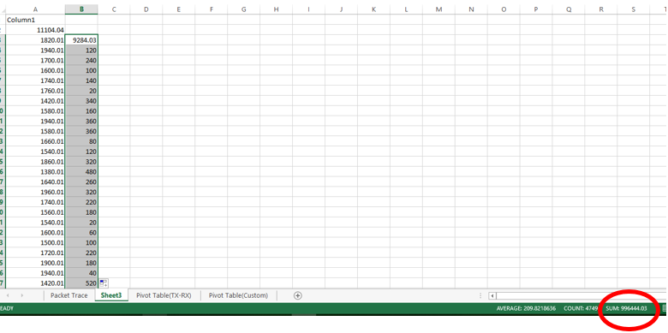

The sum obtained 996444.03 is the Packet Jitter value.

Hence, Jitter = 996444.03 = 209.8218

4750 - 1

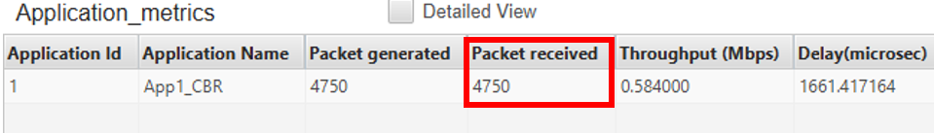

**Expected Result:** Jitter obtained in Application metrics should be same when calculated with above mentioned formula.

**Actual Result:** Same as expected

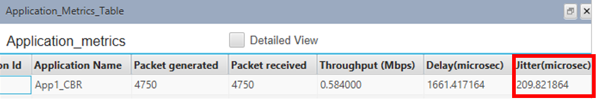

**Case 2:** Calculate Jitter when intermediate devices are present between source and destination.

Create a scenario in Internetwork as shown in the below screenshot

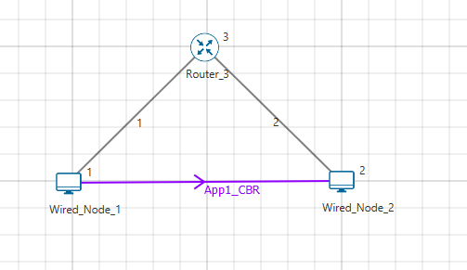

Set Inter Arrival Time as 1000000 and simulate for 10 seconds.

Calculate Jitter by using below formula,

𝐽𝑖𝑡𝑡𝑒𝑟(𝜇𝑠) = 𝑇𝑜𝑡𝑎𝑙𝑃𝑎𝑐𝑘𝑒𝑡 𝐽𝑖𝑡𝑡𝑒𝑟 𝑜𝑓 𝑎𝑙𝑙 𝑠𝑢𝑐𝑐𝑒𝑠𝑠𝑓𝑢𝑙𝑙 𝑝𝑎𝑐𝑘𝑒𝑡𝑠

𝑇𝑜𝑡𝑎𝑙 𝑁𝑢𝑚𝑏𝑒𝑟 𝑜𝑓 𝑠𝑢𝑐𝑐𝑒𝑠𝑠𝑓𝑢𝑙𝑙𝑦 𝑟𝑒𝑐𝑖𝑒𝑣𝑒𝑑 𝑝𝑎𝑐𝑘𝑒𝑡𝑠 − 1

Total Packect Jitter of all successful packets is calculated as follows:

STEP 1: Open packet trace and filter the control packets to CBR

STEP 2: Copy APP layer Arrival time and Phy Layer End Time column into separate sheet. For calculating Packet Jitter.

In this case take the difference between PHY_LAYER_END_TIME of Router_3 and APP_LAYER_ARRIVAL_TIME of Wired_Node_1 and then PHY_LAYER_END_TIME of Wired_Node_2 and APP_LAYER_ARRIVAL_TIME of Router_3 should be found manually for all the values present as shown below:

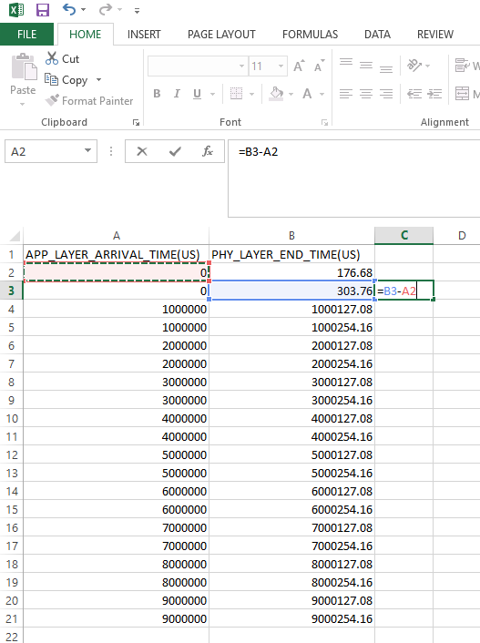

End to End Delay is obtained as shown below:

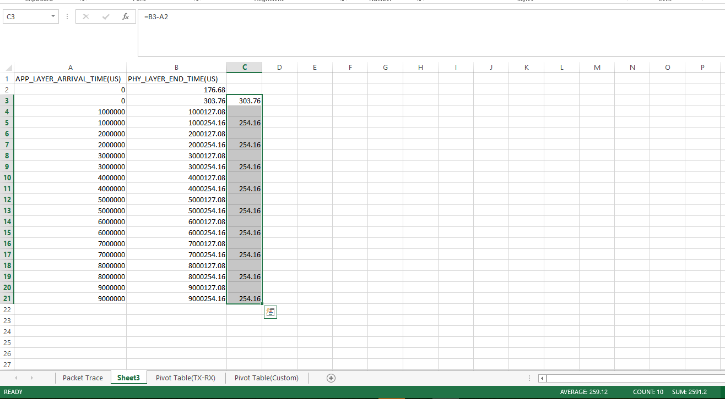

Now Packet Jitter is calculated by,

𝑃𝑎𝑐𝑘𝑒𝑡 𝐽𝑖𝑡𝑡𝑒𝑟 (𝜇𝑠) = |𝐸𝑛𝑑𝑡𝑜𝐸𝑛𝑑 𝐷𝑒𝑙𝑎𝑦 𝑜𝑓 𝐶𝑢𝑟𝑟𝑒𝑛𝑡 𝑝𝑎𝑐𝑘𝑒𝑡 − 𝐸𝑛𝑑𝑡𝑜𝐸𝑛𝑑 𝐷𝑒𝑙𝑎𝑦 𝑜𝑓 𝑃𝑟𝑒𝑣𝑖𝑜𝑢𝑠 𝑃𝑎𝑐𝑘𝑒𝑡|

and find the sum as shown below:

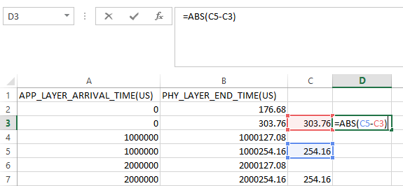

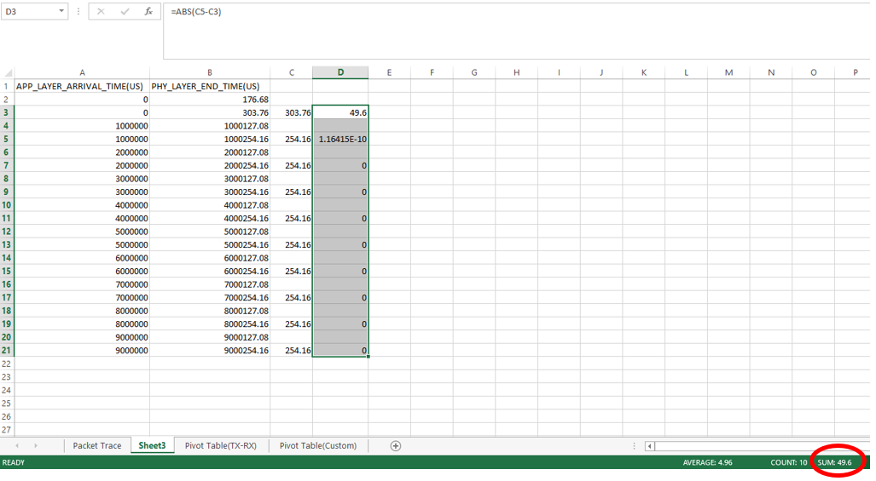

Hence, Jitter = 49.6 = 5.511

10 - 1

**Expected Result:** Jitter obtained in Application metrics should be same when calculated with above mentioned formula.

**Actual Result:** Same as expected

